Name: Mriganka Patra

Email: [mriganka.patra@cognizant.com](mailto:mriganka.patra@cognizant.com)

Emp ID: 2415820

Day 18

Sprint 1 Submission

Objective: Implement the base CRM logic with record types, automation, visibility settings, and user management

Task 1.6: As a sales manager, I want to auto-create an opportunity when a new Account is added so that sales tracking begins immediately.

1. Go to setup > Object Manager

4. 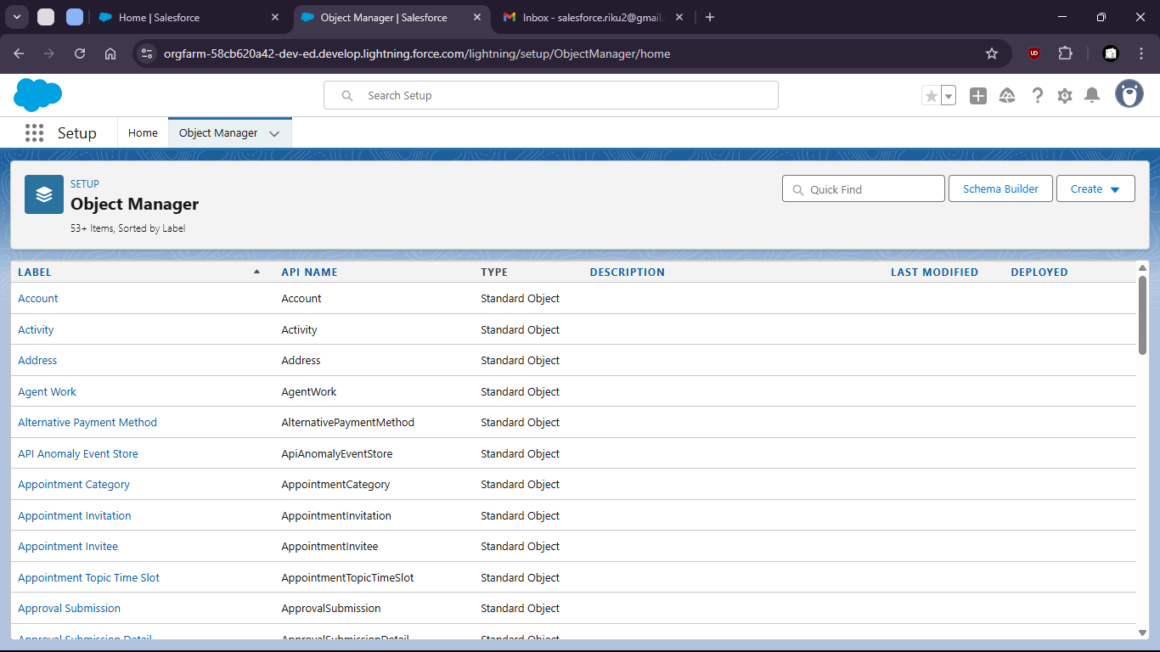
6. select opportunity

9. 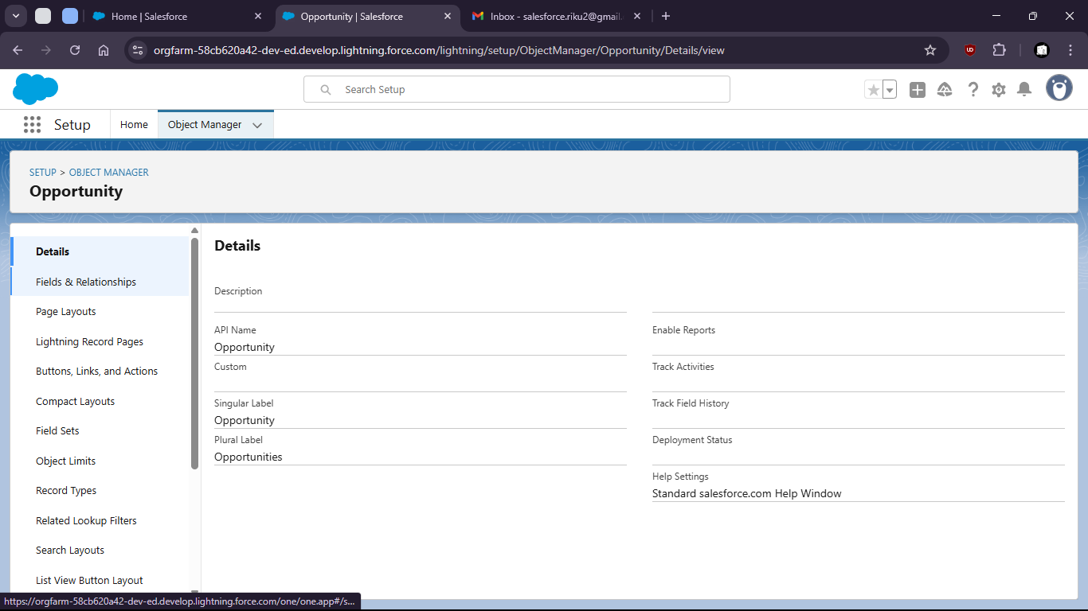
11. Go to fields and relationships
13. 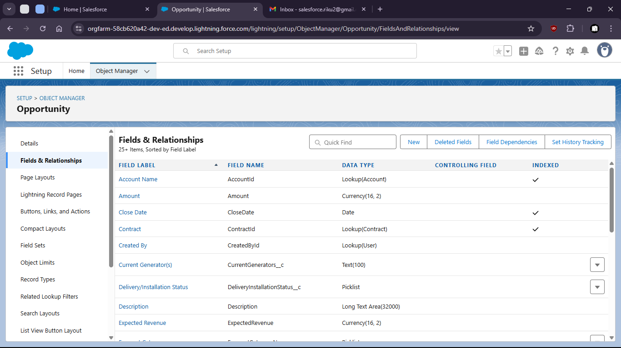

16. Create new Field “Region”

19. 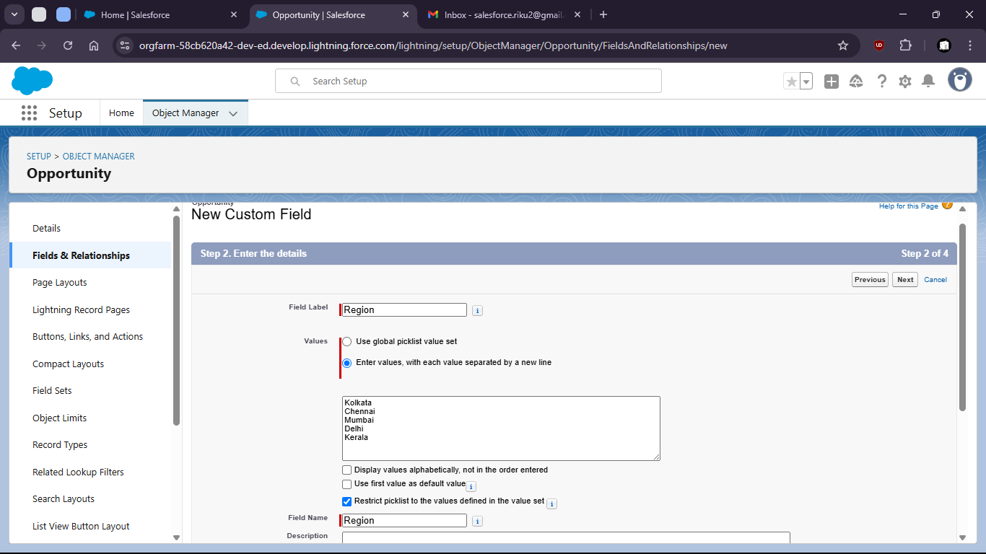

22. Now search For Reports in App Launcher

25. 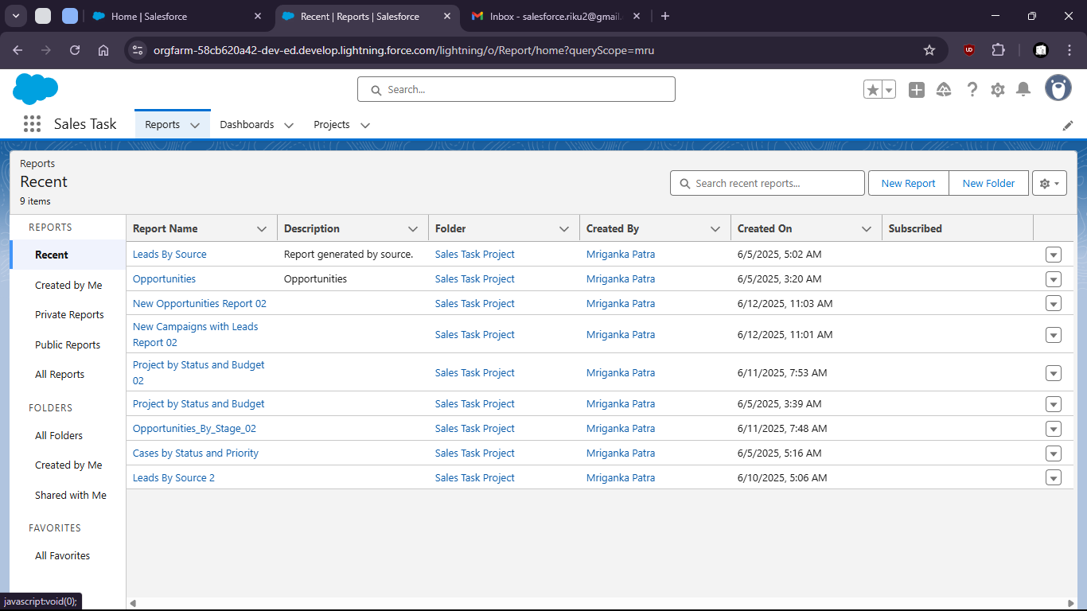

28. Create new report on Opportunities

31. 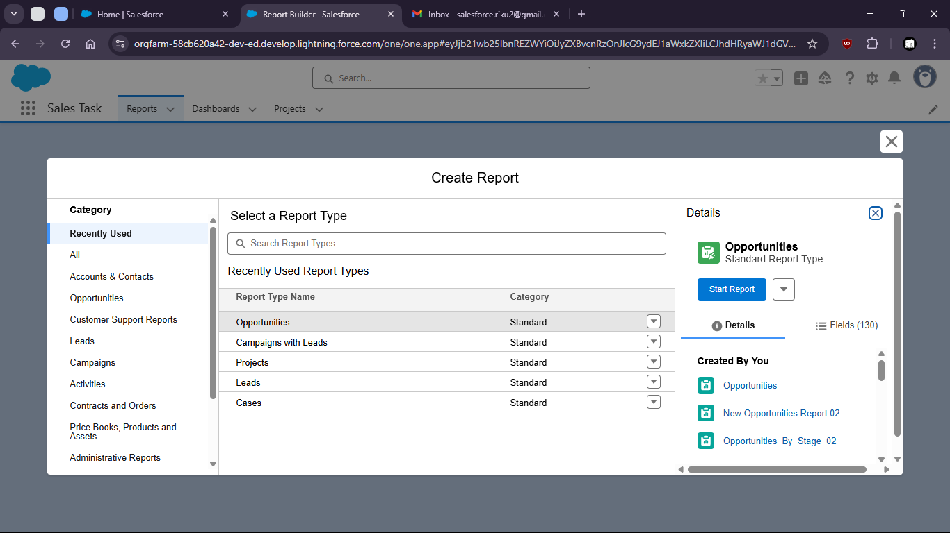

34. Group by region
36. 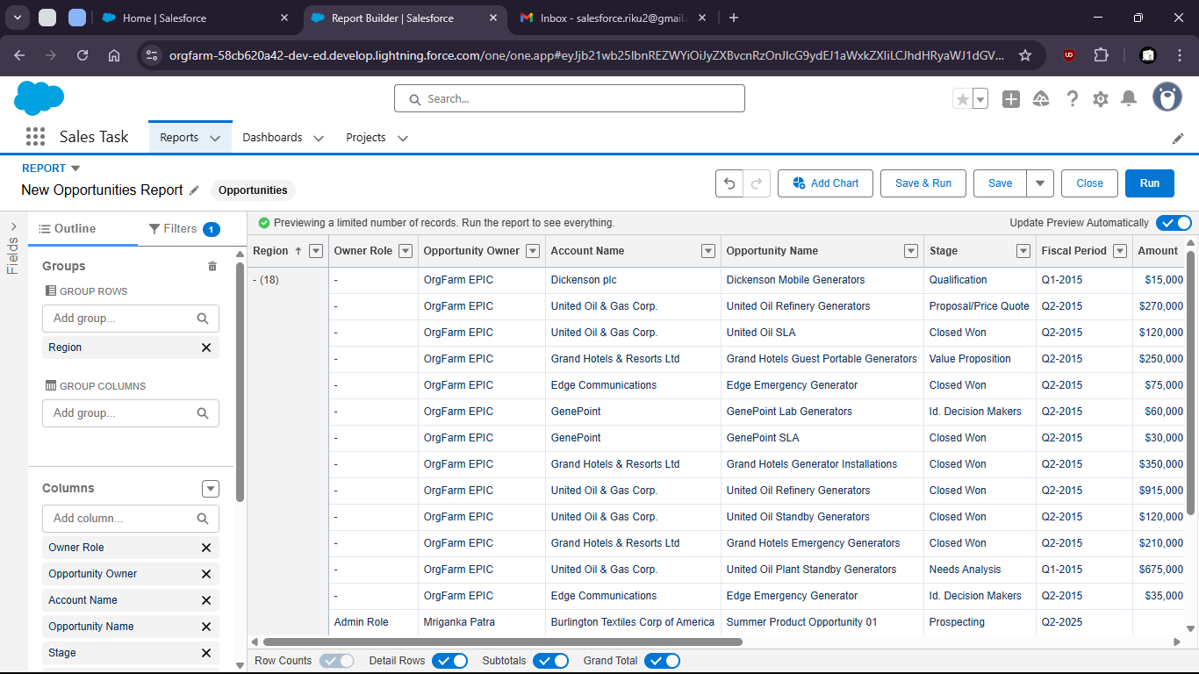

39. 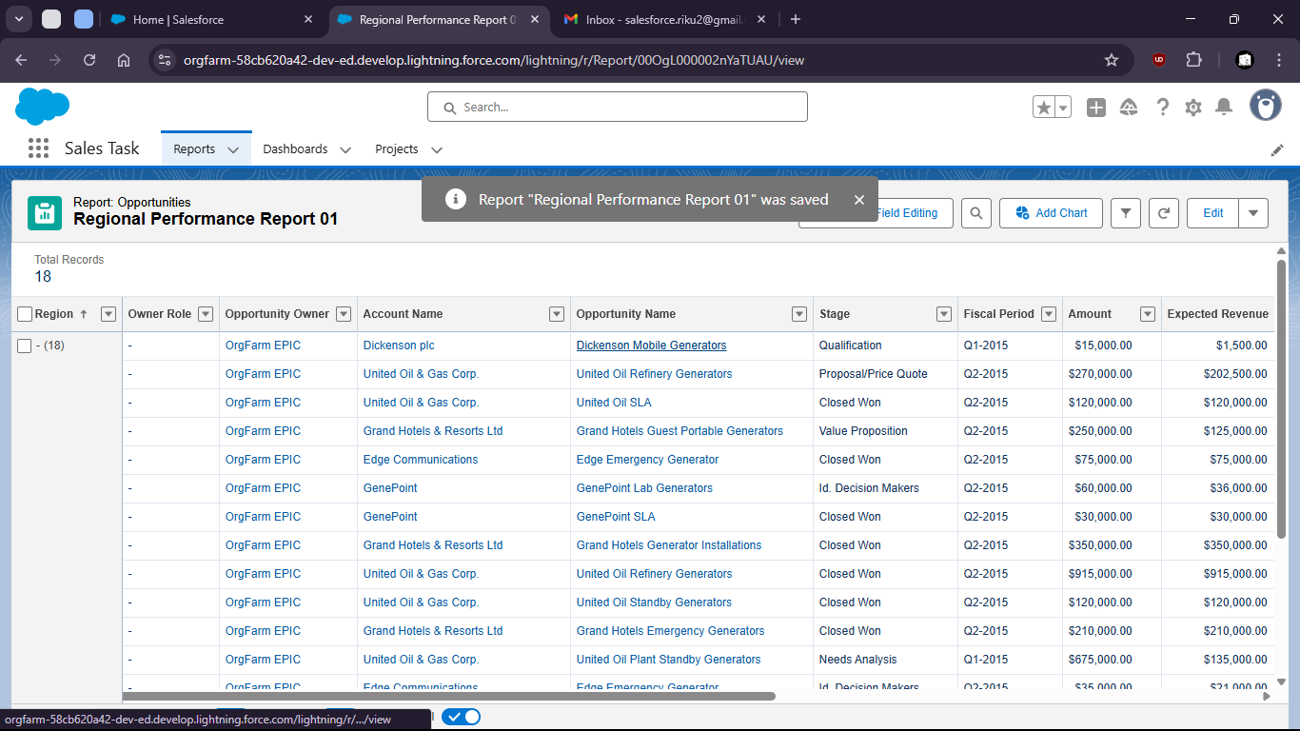

42. Create new Dashboard on the Report

45. 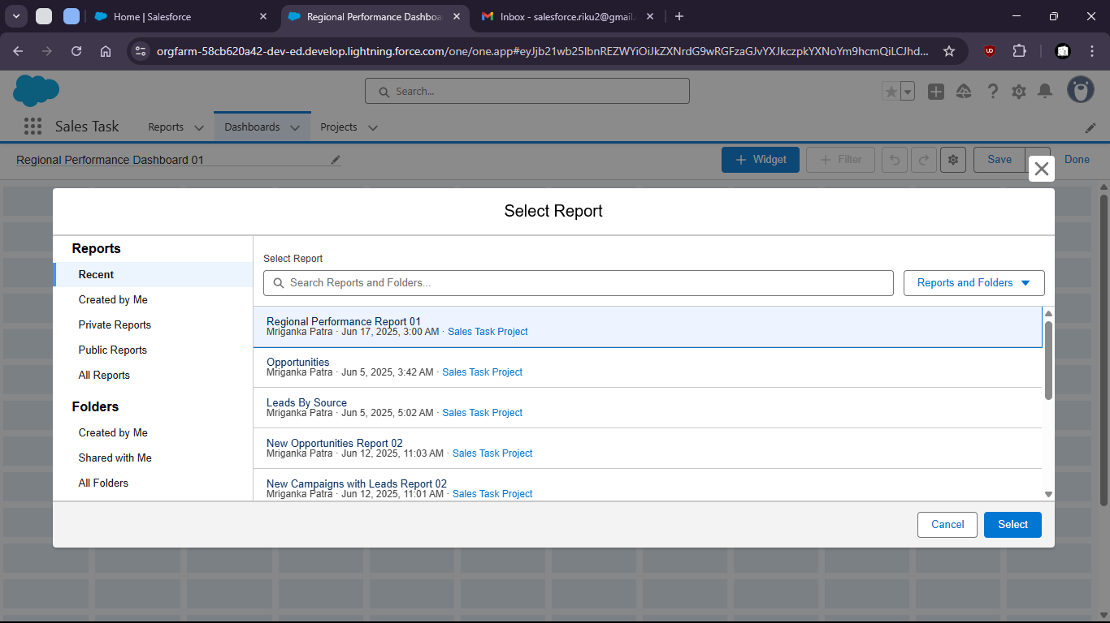
47. Add widgets for better visualization

50. 